273/1
Geography
Paper 1
July/August 2019
2½ hours

BUGANDA EXAMINATIONS COUNCIL MOCKS

Uganda Certificate of Education

GEOGRAPHY

PAPER 1

2HOURS 30 MINUTES

INSTRUCTIONS TO CANDIDATES:

- This paper consists of parts I and II
- Part I and section A of part II are compulsory
- Answer only one question from section B of part II
- Answers to all questions MUST be written in the answer booklet provided
- Any additional question(s) attempted will NOT be marked.

PART I

OBJECTIVE TYPE QUESTIONS (30 MARKS)
There are 30 compulsory questions. Each question carries one mark. Answers to this part must be written in the answer booklet provided.

1. A volcanic plug is formed when
A. molten lava solidifies in the vent
B. lava spreads over an area
C. secondary cone is eroded
D. a batholith is exposed

2. The type of settlement pattern found along river systems is
A. nucleated settlement
B. linear settlement
C. dispersed settlement
D. clustered settlement

3. The presence of ox-bow lakes on river Semiliki in Western Uganda are evidence or a river in its
A. old stage
B. youthful stage
C. mature stage
D. juvenile stage

4. Lines drawn on a map through places of the same atmospheric pressure are called
A. isotherms
B. isobars
C. isohytes
D. grid reference

5. Which of the following landing sites is found on lake Kyoga?
A. Namasale
B. Bukakata
C. Ntoroko
D. Katungulu

6. A feature joined to the bay at one end with the other end projecting into the sea is called
A. Tombolo
B. Beach
C. Spit
D. Bridge
7. Which of the following methods is used in the mining of crude oil?
A. open east
B. evaporation
C. Adit
D. Drilling

8. Which of the following sets of lakes are lava dammed?
A. Mburo and Wamala
B. Mutanda and Bunyonyi
C. Eyasi and Natron
D. Victoria and Kyoga

9. The vegetation type in East Africa which is characterized by climbing trees and plants is
A. Bush and thicket
B. Heath and Moorland
C. Tropical rain forests
D. Savannah woodland

10. Which one of the following rivers in East Africa is a tributary of river Tana?
A. Thika
B. Nzoia
C. Ruvuma
D. Pangani

11. Which of the following is an igneous rock?
A. Granite
B. Limonite
C. Quartz
D. Shale

12. The different vegetation zones found on Mt. Kilimanjaro are mainly a result of changes in
A. temperature
B. soil fertility
C. latitude
D. altitude

13. Which of the following landforms in East Africa was formed by glaciations?
A. Inselbergs
B. Aretes
C. A toll
D. Caldera

14. Which of the following is a physical weathering process?
A. Exfoliation
B. Hydrolysis
C. Oxidation
D. Carbonation

15. The flood plains of rivers in East Africa are mainly used for
A. Wildlife conservation
B. Human settlement
C. Crop cultivation
D. Animal grazing

16. Which of the following crops in East Africa is grown in green houses?
A. Vanilla
B. Citrus fruits
C. Apples
D. Flowers

17. Coral limestone in East Africa is mined at
A. Lamu
B. Mombasa
C. Mwanza
D. Lod war

18. Which of the following is a characteristic of equatorial climate in East Africa?
A. large temperature range
B. low humidity
C. double rainfall maxima
D. cool temperatures

19. Which one of the following fish species in East Africa is mainly caught in swamps?
A. Tilapia
B. Nile perch
C. Mud fish
D. Dagaa

20. Which of the following is Montane forest specie?
A. Podocarp
B. Ebony
C. Wattle
D. Baobab

21. Agriculture in East Africa is mainly dependent on
A. Transport costs
B. market
C. land
D. environmental factors

22. Watersheds in East Africa are mainly composed of
A. upland
B. depressions
C. river distributaries
D. flood plains

23. Which one of the following is an example of pelagic fish?
A. Sardines
B. Bonito
C. Tilapia
D. Nile perch

24. Which one of the following minerals in East Africa is metallic?
A. Coal
B. Salt
C. Diamond
D. Potash

25. The type of moraine dumped at the end of the glacier are called
A. lateral moraine
B. terminal moraine
C. ground moraine
D. medial moraine

26. The most common type of fish caught on Lake Tanganyika is
A. Tilapia
B. Salmon
C. Cod
D. Dagaa
27. Exotic tree species have been introduced in East Africa because they
A. are more valuable
B. have softwood
C. mature faster
D. are most resistant

28. Which of the following processes leads to the formation of lateritic soils?
A. Leaching
B. Deposition
C. Sedimentation
D. Erosion

29. Which of the following is the major tourism attraction in East Africa?
A. Cultural sites
B. Flora and fauna
C. Mountain scenery
D. Climate

30. Which one of these products is manufactured from soda ash?
A. Fertilizers
B. Tooth paste
C. Cement
D. Glass

PART II

MAPWORK, PHOTOGRAPH INTERPRETATION, FIELDWORK AND EAST AFRICA

Answer four questions from part Ii including question 1, 2, 3 which are compulsory.

SECTION A

1. COMPULSORY QUESTIONS: MAP WORK (20 MARKS)

Answer all parts of this question.

Study the 1: 50,000 (UGANDA) ALOI map extract part of sheet 33// series Y732, Edition 1-U.S.D and answer the questions that follow.

(a)(i) State the grid reference of Apuch Dam. (01mark)
(ii) Identify the physical feature found at grid reference 151636. (01mark)

(b) Calculate the;
(i) vertical interval used on the map. (02marks)
(ii) bearing of Ongom Dam from Borehole at Aloi

(c) Draw a sketch map of the area South of Northing 60 and between Easting 10 and 20 and on it mark and name;
(i) All weather loose surface roads
(ii) Permanent rivers
(iii) Aloi town council and mission
(iv) Country boundary

(d) Giving evidence from the map;
(i) Describe the relationship between relief and drainage in the area shown on the map extract. (04marks)

(ii) Describe the factors that favour any one economic activity taking place in the area shown on the map. (02marks)

2. COMPULSORY PHOTOGRAPH INTERPRETATION QUESTION (15marks)

Study the photograph provided below and answer the questions that follow.

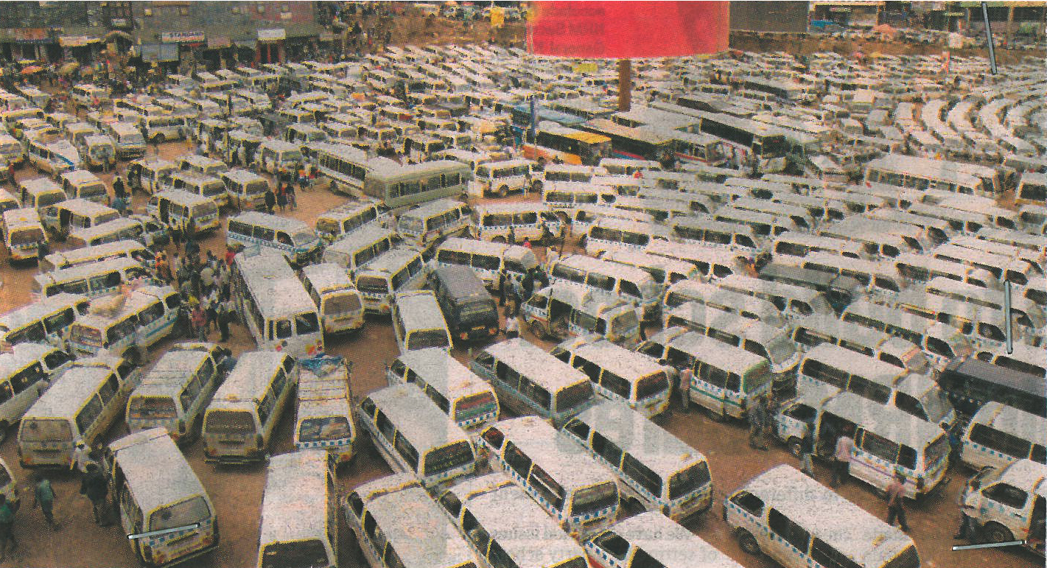

(a)(i) State with evidence, the type of photograph. (01mark)
(ii) Identify the economic activity taking place in the photograph. (01mark)

(b) Describe the factors that have favoured the economic activity identified in (a) (ii) above.
(06marks)
(c) Identify the problems faced by the economic activity. (05marks)

(d) Giving reasons for your answer, suggest an area in East Africa where the photograph could have been taken. (02marks)

3. COMPULSORY FIELDWORK QUESTION. (15marks)

Answer all parts of this question.

For any one fieldwork study you have conducted.

(a)(i) State the topic of study. (02marks)
(ii) Outline the objectives of the study. (03marks)

(b) Mention the preparations that you made before the field study. (03marks)

(c) Draw a cross section of the area studied during the fieldwork and on it mark and label
(i) physical features
(ii) man-made features (05marks)

(d) Explain how the fieldwork study enabled you to understand the geography of the area of study. (02marks)

SECTION B: EAST AFRICA

Answer only one question from this section.

4(a) Draw a sketch map of East Africa and on it mark and name
- Mountains : Rwenzori and Kilimanjaro
- Lakes : Turkana and Natron
- Rivers : Tana and Rufigi (07marks)

(b) Describe the process for the formation of river deltas in East Africa. (05marks)

(c) Explain the benefits of river deltas to the people of East Africa. (04marks)

(d) Outline the problems which are faced by the people living along river valleys in East Africa. (04marks)

5(a) Distinguish between marine fishing and fresh water fishing. (02marks)
(b)(i) Identify two fish species caught in the Wetlands of East Africa. (02marks)
(ii) State one fishing method used to catch fish from the Wetlands in East Africa.(01mark)

(c) Describe the conditions that have favoured the development of the Marine fishing in East Africa. (06marks)

(d)(i) Explain the benefits of the fishing industry to the people of East Africa. (05marks)
(ii) Outline the problems faced in the extraction of marine resources in East Africa.
(04marks)
6. Study the table below showing mineral production in Uganda (2004 – 2006) and answer the questions that follow.
Mineral | 2004(000) tones | 2006(000) tones
Cobalt | 460 | 335
Gypsum | 190 | 93
Wolfram | 80 | 23
Beryl | 204 | 00

Adopted: NEMA 2006/7, state of the environment report for Uganda P102.

(a)(i) Draw a bar graph to show the mineral production in Uganda in 2004. (06marks)
(ii) Calculate the percentage change in the production of cobalt and Wolfram in Uganda between 2004 and 2006. (02marks)

(b) Describe the factors that have led to the trend of mineral production in Uganda shown in the table above. (04marks)

(c) Explain the contribution of the mining sector to the economic development of Uganda.
(05marks)
(d) Outline the effects of mining activity on the physical environment in East Africa.
(03marks)

7. Study the map of Mwea-Tebere irrigation scheme and answer the questions that follow.
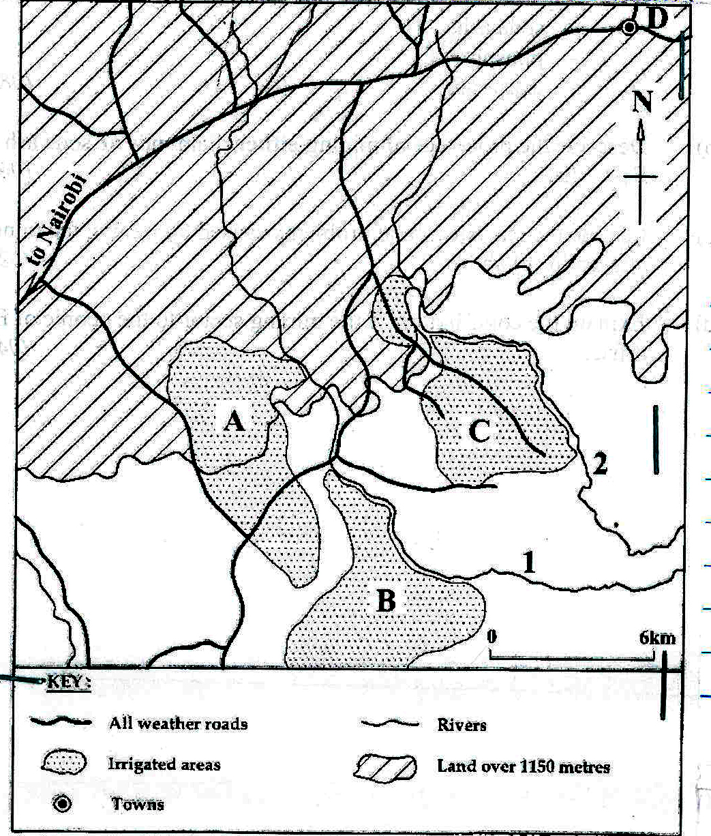

(a) Name the;
(i) Rivers marked 1 and 2
(ii) Irrigation blocks A, B, C
(iii) Town marked D (06marks)

(b) Describe the physical factors which have influenced the location of Mwea-Tebere irrigation scheme in Kenya. (05marks)

(c) Explain the contribution of irrigation farming to the economic development of Kenya.
(05marks)
(d) Outline the problems which are facing the irrigation schemes in East Africa. (04marks)

END

